Generative Representation of Aggregate Brain Activity: A Deep Autoencoder Approach for EEG Topoplot Summarization

Tobias Mikha Sulistiyo^{[1]*}, Authors Name/s (Author)^{[2]}, Authors Name/s (Author)^{[3]}
line 1 (of Affiliation): dept. name of organization^{[1], [2], [3]}
line 2-name of organization, acronyms acceptable
Jakarta, Indonesia
line 4-e-mail address if desired^{[1], [2], [3]}

Abstract— Creating valid group-level visualizations remains a significant hurdle in EEG analysis. Traditional methods, which typically rely on pixel-wise arithmetic means, often fail to account for spatial variations and tend to incorporate background noise into the final image. To address this, we employed a Deep Convolutional Autoencoder (CAE) to average two-dimensional EEG topoplots. Instead of averaging raw images, our approach aggregates data within the latent feature space. This allows the model to capture essential structural patterns while effectively filtering out baseline artifacts. We validated this method using a dataset of adolescent responses to addiction-related terminology, categorized into Normal and At-Risk groups. The resulting visualizations highlighted clear distinctions in neural processing: Normal respondents showed efficient, focused activity in frontal-temporal regions. In contrast, At-Risk adolescents displayed impulsive, widespread activation during fast responses and an occipital-temporal dominance—suggesting attentional bias—during slow responses. These findings indicate that latent-space aggregation offers a more robust alternative to standard averaging, providing clearer insights into the neurocognitive dynamics of addiction more detail the entire article.
Keywords— Deep Convolutional Autoencoder (CAE), Latent Space Representation, EEG Data Augmentation, Unsupervised Learning, Image Reconstruction.

Introduction
Visualizing EEG signals in two dimensions is one way to represent EEG signals for easier analysis. This technique enables the spatial distribution of electrical activity across the scalp to be mapped onto a two-dimensional image, providing a clearer and more intuitive depiction of the underlying brain dynamics [1], [2]. Using this method helps both clinicians and non-expert users more easily understand EEG activity at a given point in time. In population-based studies, however, the primary challenge does not lie in analyzing individual subjects, but rather in integrating data from multiple participants to obtain a valid and reliable group-level representation [3]. Data aggregation therefore becomes essential for identifying spatial patterns that accurately differentiate conditions within the plotted scalp maps [2].
However, aggregation methods exhibit a fundamental limitation that is often overlooked. The standard approach still relies heavily on computing the pixel-wise arithmetic mean across all images within a dataset. Such averaging procedures can obscure meaningful spatial variations, reduce inter-subject specificity, and potentially distort group-level representations of EEG activity [4]. In many EEG datasets, line-shaped activation patterns tend to be consistently detected as meaningful neural activity. However, when these patterns vary across subjects or trials, the pixel-wise averaging process inevitably incorporates these variations into the final aggregated image. As a result, the computed average may become biased or distorted at specific pixel locations, leading to an inaccurate representation of the underlying neural signal.
Recent progress in deep learning has opened new opportunities to address the limitations of traditional statistical aggregation methods. One approach that has become increasingly popular is the use of Convolutional Autoencoders (CAEs), which have shown strong potential in representing EEG data more effectively than simple pixel averaging [5], [6]. Instead of working directly with raw images, autoencoders learn to compress the input into a latent feature space that captures the most relevant structure of the data.
This latent representation allows aggregation to be done at the feature level, where variations in spatial patterns are handled more naturally. After the latent vectors are combined—often through a simple mean or another statistical operation, the decoder can reconstruct an image that reflects the shared characteristics of the dataset [7]. Several studies have reported that this strategy preserves important EEG topographic features much better than pixel-wise averaging, which tends to blur or distort spatial information when subjects differ substantially. Overall, this generative approach provides a more reliable way of producing summary images, especially when the dataset contains heterogeneous spatial activation patterns.
The objective of this study is to implement a Deep Convolutional Autoencoder as a two-dimensional visualization method for EEG signals. This approach is further supported by using a dataset capturing adolescents’ brain responses to addiction-related terminology. The present work extends earlier analyses conducted by Wijayanto et al [3], [8]. on the same dataset, which previously explored one-dimensional and two-dimensional EEG characteristics in adolescents exposed to addiction-related cues. The dataset comprises respondents classified into normal and at-risk categories, with response variables represented by fast and slow patterns. By applying this deep learning–based generative framework, the study contributes methodological novelty in both EEG visualization and signal interpretation.
More specifically, this study contributes to the development of a Latent-Space Aggregation approach for representing the average patterns of brain activity. Through this method, the model can generate aggregated representations derived from the existing dataset. The proposed generative framework offers a potential solution for estimating group-level brain activity in both normal and at-risk respondent categories, thereby revealing distinctions in activation patterns associated with fast and slow responses. The resulting visualizations also provide empirical support for hypotheses regarding how normal and at-risk adolescents cognitively respond to addiction-related terminology. In addition, this work introduces a form of methodological and thematic novelty within EEG research in Indonesia, particularly in the context of addiction terminology and adolescent neurocognitive responses.

Methods

Datasets and Distribution
This study utilizes a dataset obtained from the Telkom University Dataverse (https://doi.org/10.34820/FK2/GW8JIV) [8]. The dataset contains both one-dimensional and two-dimensional EEG recordings capturing neural responses to addiction-related terminology. The stimuli presented during EEG acquisition was based on the Go/No-Go Association Task (GNAT). The dataset includes recordings from twelve adolescent participants, categorized into normal and at-risk groups. The primary focus of this research is the analysis of the two-dimensional EEG representations, from which the model generates average responses for both fast and slow conditions across the two respondent categories. This approach aims to provide a clearer depiction of group-level neural activation patterns associated with differing response speeds.
The total dataset used in this study consists of 812 topoplots images. Each respondent’s data is categorized into fast and slow responses. The fast category corresponds to reaction times between 0 s and 0.5 s after stimulus onset, while the slow category represents responses occurring between 0.5 s and 1 s. The respondent groups are divided into two categories. The normal group contributes 492 images, comprising 260 fast responses and 232 slow responses. Meanwhile, the at-risk group contributes 320 images, consisting of 153 fast responses and 167 slow responses.

Autoencoder Architecture for Latent Space Aggregation
In designing the system, this study employs a Deep Convolutional Autoencoder (CAE). A CAE is an unsupervised learning architecture developed for training on high-dimensional data such as images. Unlike conventional autoencoders that rely solely on fully connected layers, a CAE incorporates convolutional operations to preserve the structural integrity of the input data [9]. This characteristic is essential in the context of EEG topoplots, where neighboring electrodes exhibit strong spatial correlations that must be retained. Structurally, the architecture consists of two symmetrical networks: an encoder pathway that functions as a feature extractor, and a decoder pathway responsible for reconstructing the input topoplots images.
The encoding process represents the input topoplots and transforms it through a series of convolutional operations. Each convolutional layer is computed using the following equation:
$$h_{k}=σ(W_{k}* h_{k-1}+ b_{k})$$ | (1)
where * denotes the convolution operator $W_{k}$ is the learnable kernel matrix, $b_{k}$ is the bias term, and $h_{k-1}$ is the input feature map [10], [11]. To reduce the spatial dimensions and achieve translational invariance, a Max-Pooling operation is applied after each convolutional block. This operation retains the maximum value within each patch, progressively reducing the input resolution from 128 x 128 to an abstract 16 x 16. feature representation.
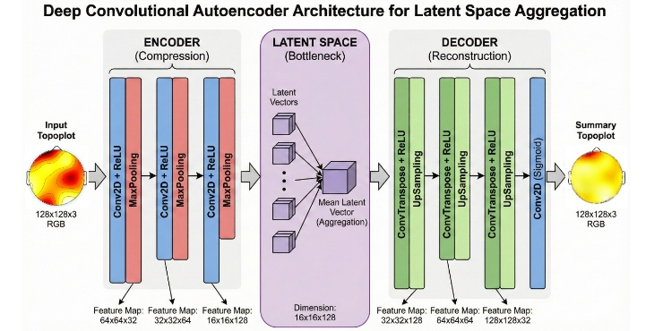
Figure 1. Schematic diagram of the proposed latent space aggregation framework.
The contribution of this study lies in the aggregation method performed within the latent space, as illustrated in the middle block of Figure 1. Unlike conventional approaches that compute the average directly from high-dimensional pixel values, the proposed method calculates the average from compressed feature representations. This latent-space averaging enables a more meaningful and compact characterization of EEG topoplots patterns, capturing essential structure while reducing noise and redundancy. High-dimensional pixel data are susceptible to biased artifacts. Therefore, a compression step is applied to remove such distortions before any averaging is performed at the pixel level.
Instead of computing the average across all individual samples, the averaging process is performed on input topoplots groups that have already been mapped into specific categories for example, the at-risk–fast group. The mean vector is then computed using the following equation:
$$z_{avg}=\frac{1}{N}\sum_{i=1}^{N}{z_{i}}$$ | (2)
Where N denotes the total number of samples within the corresponding category, and zₐᵥg represents the averaged latent vector computed for that respondent group [12], [13]. Once this latent average vector is obtained, it is then passed through the decoder to generate a reconstructed topoplots image. This technique preserves the sharp gradient characteristics embedded in the averaged latent representation, allowing the resulting visualization to retain meaningful structural patterns.

Prepare Your Paper Before Styling
  - Normal – Fast Category Respondents
Within the Normal category, the dataset comprises a total of 492 topoplots. These images were stratified based on reaction latencies recorded during the GNAT assessment, yielding 260 instances in the 'fast' category (reaction time < 0.5 s) and 232 in the 'slow' category (reaction time > 0.5 s). This segmentation is supported by prior literature suggesting that rapid responses particularly those under 250 ms are indicative of 'honest' or instinctive processing [14]. Consequently, the application of GNAT provides an optimal framework for isolating authentic neural responses within the analysis.
A.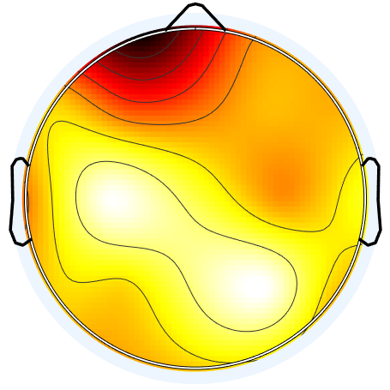B.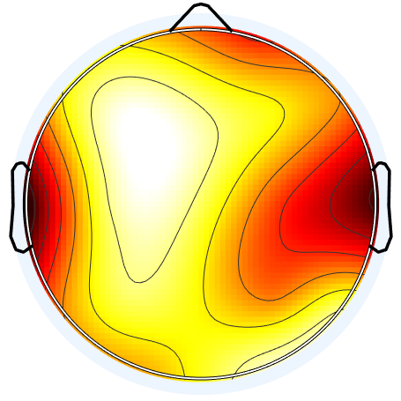C.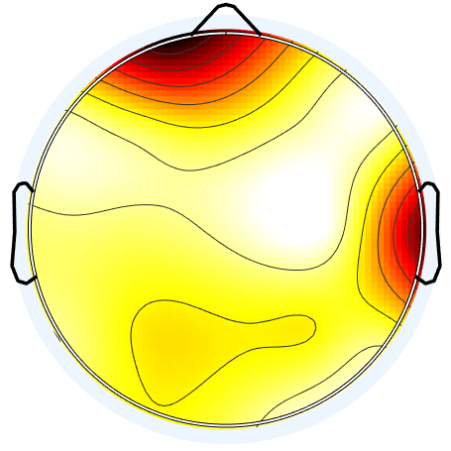
Figure 2. Examples of Normal category in fast responses
Figure 2 visualizes the raw topoplots, exposing a marked inconsistency in how different subjects respond. The focal points of neural activity shift unpredictably ranging from localized left frontal activation in Respondent A, to bilateral temporal patterns in Respondent B, and a more diffuse frontal-temporal engagement in Respondent C. These examples illustrate that sharp activation peaks are not a constant feature in raw data. Furthermore, a dark baseline artifact dominates the background of these images. To prevent this non-informative noise from distorting the final aggregate, it must be suppressed before the averaging stage begins.
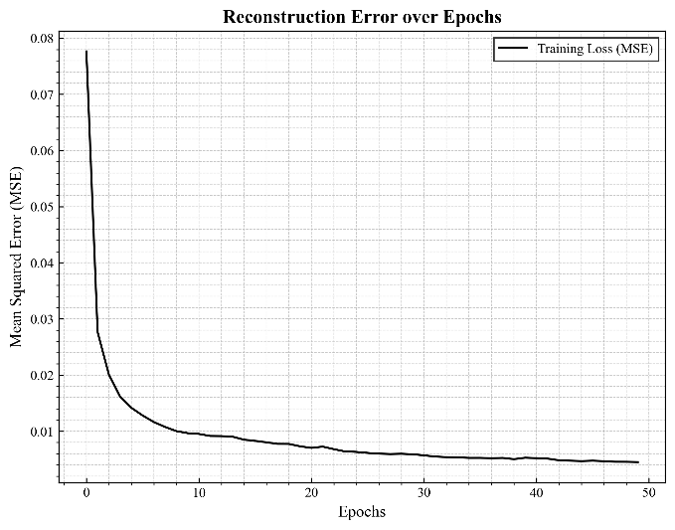
Figure 3. Reconstruction models error over epoch for Normal-Fast
To achieve high-fidelity image reconstruction, the model relies on the encoder’s ability to map input data into a compressed latent representation. The training stability of this process is plotted in Figure 3, which tracks the error reduction trajectory over time. By the 50th epoch, the model converged successfully, driving the loss value down to below 0.01. This low-error state indicates that the network has effectively learned to isolate meaningful neural features from background noise. Consequently, we applied these trained parameters to the raw dataset to suppress the non-informative dark baseline. The practical impact of this denoising step which clarifies the active neural regions is visually demonstrated across Figures 4, 5, and 6.
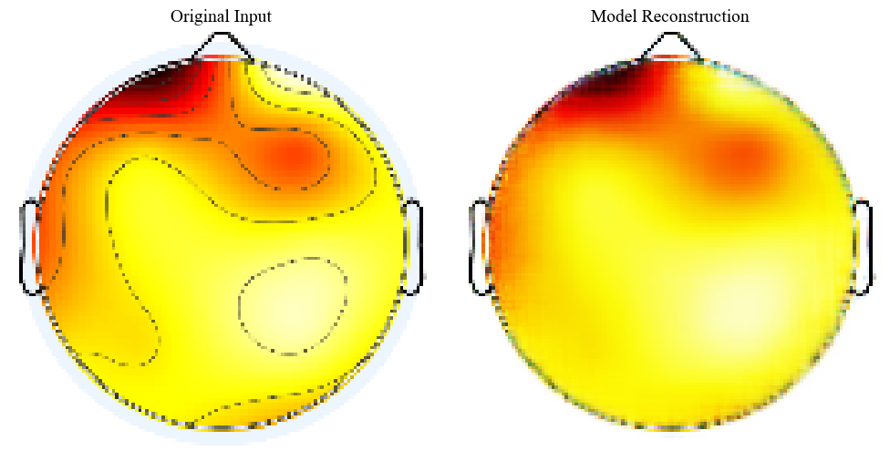
Figure 4. Reconstructed EEG output for Respondent A after baseline removal
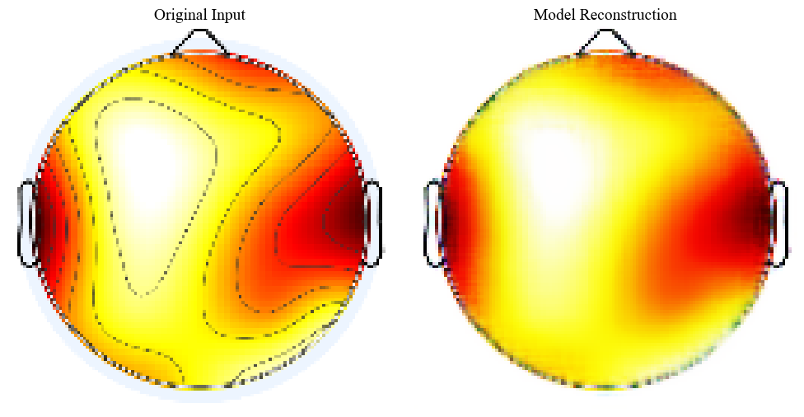
Figure 5. Reconstructed EEG output for Respondent B after baseline removal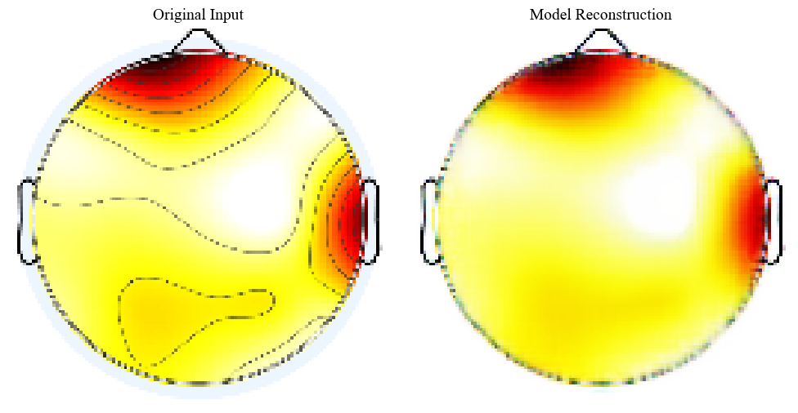
Figure 6. Reconstructed EEG output for Respondent C after baseline removal.
The efficacy of the training process in eliminating baseline artifacts is visually demonstrated in Figures 4 through 6. As observed in these reconstructions, the model successfully isolates regions of genuine neural activity, effectively stripping away the dark background noise. Subsequently, these cleaned topoplots were subjected to an aggregation process. Specifically, for the 'Fast' response category, the averaging was performed not on raw pixels, but within the latent space representation to capture the shared structural features. The final aggregated output resulting from this method is presented in Figure 7.
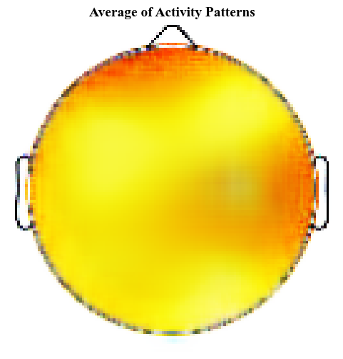
Figure 7. Average of activity patterns in normal-fast category respondent
As shown in Figure 7, the averaged results for the Normal-Fast category display a relatively diffuse neural signal. The activity does not cluster in a single point but spreads across the map in a gradient of yellow and orange. Deep orange tones, representing the highest intensity, dominate the frontal lobe, with moderate activation extending into the temporal sections. This heavy reliance on the frontal cortex implies a state of high focus and readiness to respond [15]. Such a configuration is unsurprising, as the interplay between frontal and temporal networks is a well-documented mechanism in cognitive response tasks [16], [17].
  - Normal – Slow Category Respondents
For the Normal respondents exhibiting slower reaction times (Normal-Slow), the dataset comprises 232 topoplots. This group was processed using the identical generative framework applied to the Fast category to ensure methodological consistency. To capture the diversity of the subjects within this subset, specific samples were selected from the total pool for comparative analysis. These representative instances, which illustrate the varying activation patterns, are displayed in Figure 8.
D.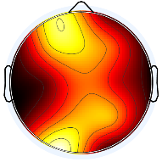E.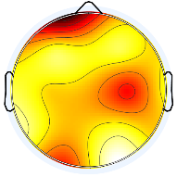F.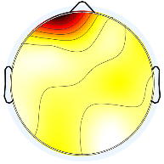
Figure 8. Examples of Normal category in slow responses
A closer inspection of the Normal-Slow dataset reveals a marked increase in signal heterogeneity. As illustrated by the three sample variations, neural activity becomes far less uniform when respondents require more time to process addiction-related terminology. It appears that this extended processing window introduces a higher degree of individual variability in how the brain engages with the stimuli, resulting in divergent patterns. Despite this complexity, we proceeded with the training phase using the same autoencoder configuration applied to the Normal-Fast group. The model’s performance in learning these diverse features is tracked in the training loss graph below.
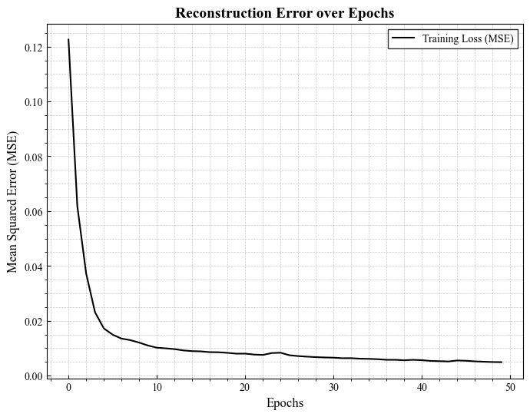
Figure 9. Reconstruction models error over epoch for normal-slow
The training progression, as plotted in Figure 9, demonstrates a consistent downward trajectory in Mean Squared Error (MSE) across all epochs. By the 50th iteration, the model achieved convergence, driving the error rate down to below 0.01. Interestingly, despite the higher variability inherent in this dataset, the loss pattern closely mirrors the stability observed in the Normal-Fast category. This suggests that the autoencoder is robust enough to handle the irregular patterns of slow responders without overfitting. The resulting generative outputs for the Normal-Slow group are presented below.
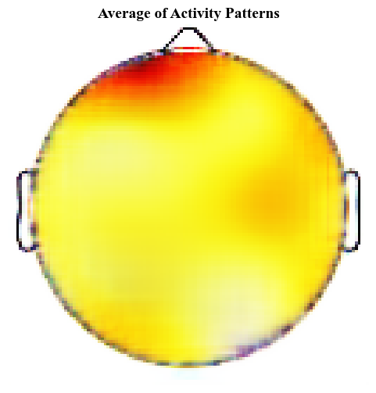

  - At Risk – Fast Category Respondents
Within the Normal category, the dataset comprises a total of 492 topoplots. These images were stratified based on reaction latencies recorded during the GNAT assessment, yielding 260 instances in the 'fast' category (reaction time < 0.5 s) and 232 in the 'slow' category (reaction time > 0.5 s). This segmentation is supported by prior literature suggesting that rapid responses particularly those under 250 ms are indicative of 'honest' or instinctive processing [14]. Consequently, the application of GNAT provides an optimal framework for isolating authentic neural responses within the analysis.
  - At Risk – Slow Category Respondents
Within the Normal category, the dataset comprises a total of 492 topoplots. These images were stratified based on reaction latencies recorded during the GNAT assessment, yielding 260 instances in the 'fast' category (reaction time < 0.5 s) and 232 in the 'slow' category (reaction time > 0.5 s). This segmentation is supported by prior literature suggesting that rapid responses particularly those under 250 ms are indicative of 'honest' or instinctive processing [14]. Consequently, the application of GNAT provides an optimal framework for isolating authentic neural responses within the analysis.
A.B.C.
Figure 10. Examples of Normal category in fast responses
Figure 2 visualizes the raw topoplots, exposing a marked inconsistency in how different subjects respond. The focal points of neural activity shift unpredictably ranging from localized left frontal activation in Respondent A, to bilateral temporal patterns in Respondent B, and a more diffuse frontal-temporal engagement in Respondent C. These examples illustrate that sharp activation peaks are not a constant feature in raw data. Furthermore, a dark baseline artifact dominates the background of these images. To prevent this non-informative noise from distorting the final aggregate, it must be suppressed before the averaging stage begins.
Figure 11. Reconstruction models error over epoch for Normal-Fast
To achieve high-fidelity image reconstruction, the model relies on the encoder’s ability to map input data into a compressed latent representation. The training stability of this process is plotted in Figure 3, which tracks the error reduction trajectory over time. By the 50th epoch, the model converged successfully, driving the loss value down to below 0.01. This low-error state indicates that the network has effectively learned to isolate meaningful neural features from background noise. Consequently, we applied these trained parameters to the raw dataset to suppress the non-informative dark baseline. The practical impact of this denoising step which clarifies the active neural regions is visually demonstrated across Figures 4, 5, and 6.
Figure 12. Reconstructed EEG output for Respondent A after baseline removal
Figure 13. Reconstructed EEG output for Respondent B after baseline removal
Figure 14. Reconstructed EEG output for Respondent C after baseline removal.
The efficacy of the training process in eliminating baseline artifacts is visually demonstrated in Figures 4 through 6. As observed in these reconstructions, the model successfully isolates regions of genuine neural activity, effectively stripping away the dark background noise. Subsequently, these cleaned topoplots were subjected to an aggregation process. Specifically, for the 'Fast' response category, the averaging was performed not on raw pixels, but within the latent space representation to capture the shared structural features. The final aggregated output resulting from this method is presented in Figure 7.
Figure 15. Average of activity patterns in normal-fast category respondent
As shown in Figure 7, the averaged results for the Normal-Fast category display a relatively diffuse neural signal. The activity does not cluster in a single point but spreads across the map in a gradient of yellow and orange. Deep orange tones, representing the highest intensity, dominate the frontal lobe, with moderate activation extending into the temporal sections. This heavy reliance on the frontal cortex implies a state of high focus and readiness to respond [15]. Such a configuration is unsurprising, as the interplay between frontal and temporal networks is a well-documented mechanism in cognitive response tasks [16], [17].

Abbreviations and Acronyms
Define abbreviations and acronyms the first time they are used in the text, even after they have been defined in the abstract. Abbreviations such as IEEE, SI, MKS, CGS, sc, dc, and rms do not have to be defined. Do not use abbreviations in the title or heads unless they are unavoidable.

Units
- Use either SI (MKS) or CGS as primary units. (SI units are encouraged.) English units may be used as secondary units (in parentheses). An exception would be the use of English units as identifiers in trade, such as “3.5-inch disk drive.”
- Avoid combining SI and CGS units, such as current in amperes and magnetic field in oersteds. This often leads to confusion because equations do not balance dimensionally. If you must use mixed units, clearly state the units for each quantity that you use in an equation.
- Do not mix complete spellings and abbreviations of units: “Wb/m2” or “webers per square meter,” not “webers/m2.” Spell units when they appear in text: “...a few henries,” not “...a few H.”
Identify applicable sponsor/s here. If no sponsors, delete this text box (sponsors).
- Use a zero before decimal points: “0.25,” not “.25.” Use “cm3,” not “cc.” (bullet list)

Equations
The equations are an exception to the prescribed specifications of this template. You will need to determine whether or not your equation should be typed using either the Times New Roman or the Symbol font (please no other font). To create multileveled equations, it may be necessary to treat the equation as a graphic and insert it into the text after your paper is styled.
Number equations consecutively. Equation numbers, within parentheses, are to position flush right, as in (1), using a right tab stop. To make your equations more compact, you may use the solidus ( / ), the exp function, or appropriate exponents. Italicize Roman symbols for quantities and variables, but not Greek symbols. Use a long dash rather than a hyphen for a minus sign. Punctuate equations with commas or periods when they are part of a sentence, as in
$f\left(x\right)=\frac{\sum_{k=1}^{n}{\sum_{i=1}^{5}{(F_{ki}xB_{ki})}}}{n}$ (1)
Note that the equation is centered using a center tab stop. Be sure that the symbols in your equation have been defined before or immediately following the equation. Use “(1),” not “Eq. (1)” or “equation (1),” except at the beginning of a sentence: “Equation (1) is ...”

Some Common Mistakes
- The word “data” is plural, not singular.
- The subscript for the permeability of vacuum μ₀, and other common scientific constants, is zero with subscript formatting, not a lowercase letter “o.”
- In American English, commas, semi-/colons, periods, question and exclamation marks are located within quotation marks only when a complete thought or name is cited, such as a title or full quotation. When quotation marks are used, instead of a bold or italic typeface, to highlight a word or phrase, punctuation should appear outside of the quotation marks. A parenthetical phrase or statement at the end of a sentence is punctuated outside of the closing parenthesis (like this). (A parenthetical sentence is punctuated within the parentheses.)
- A graph within a graph is an “inset,” not an “insert.” The word alternatively is preferred to the word “alternately” (unless you really mean something that alternates).
- Do not use the word “essentially” to mean “approximately” or “effectively.”
- In your paper title, if the words “that uses” can accurately replace the word using, capitalize the “u”; if not, keep using lower-cased.
- Be aware of the different meanings of the homophones “affect” and “effect,” “complement” and “compliment,” “discreet” and “discrete,” “principal” and “principle.”
- Do not confuse “imply” and “infer.”
- The prefix “non” is not a word; it should be joined to the word it modifies, usually without a hyphen.
- There is no period after the “et” in the Latin abbreviation “et al.”
- The abbreviation “i.e.” means “that is,” and the abbreviation “e.g.” means “for example.”
An excellent style manual for science writers is [7].

Using the Template
After the text edit has been completed, the paper is ready for the template. Duplicate the template file by using the Save As command, and use the naming convention prescribed by your conference for the name of your paper. In this newly created file, highlight all of the contents and import your prepared text file. You are now ready to style your paper; use the scroll down window on the left of the MS Word Formatting toolbar.

Authors and Affiliations
The template is designed so that author affiliations are not repeated each time for multiple authors of the same affiliation. Please keep your affiliations as succinct as possible (for example, do not differentiate among departments of the same organization). This template was designed for two affiliations.

For author/s of only one affiliation (Heading 3): To change the default, adjust the template as follows.

Selection (Heading 4): Highlight all author and affiliation lines.

Change number of columns: Select the Columns icon from the MS Word Standard toolbar and then select “1 Column” from the selection palette.

Deletion: Delete the author and affiliation lines for the second affiliation.

For author/s of more than two affiliations: To change the default, adjust the template as follows.

Selection: Highlight all author and affiliation lines.

Change number of columns: Select the “Columns” icon from the MS Word Standard toolbar and then select “1 Column” from the selection palette.

Highlight author and affiliation lines of affiliation 1 and copy this selection.

Formatting: Insert one hard return immediately after the last character of the last affiliation line. Then paste down the copy of affiliation 1. Repeat as necessary for each additional affiliation.

Reassign number of columns: Place your cursor to the right of the last character of the last affiliation line of an even numbered affiliation (e.g., if there are five affiliations, place your cursor at end of fourth affiliation). Drag the cursor up to highlight all of the above author and affiliation lines. Go to Column icon and select “2 Columns”. If you have an odd number of affiliations, the final affiliation will be centered on the page; all previous will be in two columns.

Identify the Headings
Headings, or heads, are organizational devices that guide the reader through your paper. There are two types: component heads and text heads.
Component heads identify the different components of your paper and are not topically subordinate to each other. Examples include ACKNOWLEDGMENTS and REFERENCES, and for these, the correct style to use is “Heading 5.” Use “figure caption” for your Figure captions, and “table head” for your table title. Run-in heads, such as “Abstract,” will require you to apply a style (in this case, italic) in addition to the style provided by the drop down menu to differentiate the head from the text.
Text heads organize the topics on a relational, hierarchical basis. For example, the paper title is the primary text head because all subsequent material relates and elaborates on this one topic. If there are two or more sub-topics, the next level head (uppercase Roman numerals) should be used and, conversely, if there are not at least two sub-topics, then no subheads should be introduced. Styles named “Heading 1,” “Heading 2,” “Heading 3,” and “Heading 4” are prescribed.

Figures and Tables

Positioning Figures and Tables: Place figures and tables at the top and bottom of columns. Avoid placing them in the middle of columns. Large figures and tables may span across both columns. Figure captions should be below the figures; table heads should appear above the tables. Insert figures and tables after they are cited in the text. Use the abbreviation “Fig. 1,” even at the beginning of a sentence.
- Table Styles
Table Head | Table Column Head
Table Head | Table column subhead | Subhead | Subhead
copy | More table copyª

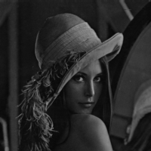
- Example of a figure caption. (figure caption)
Figure Labels: Use 8 point Times New Roman for Figure labels. Use words rather than symbols or abbreviations when writing Figure axis labels to avoid confusing the reader. As an example, write the quantity “Magnetization,” or “Magnetization, M,” not just “M.” If including units in the label, present them within parentheses. Do not label axes only with units. In the example, write “Magnetization (A/m)” or “Magnetization (A ( m(1),” not just “A/m.” Do not label axes with a ratio of quantities and units. For example, write “Temperature (K),” not “Temperature/K.”

Acknowledgment (Heading 5)
The preferred spelling of the word “acknowledgment” in America is without an “e” after the “g.” Avoid the stilted expression “one of us (R. B. G.) thanks ...”. Instead, try “R. B. G. thanks...”. Put sponsor acknowledgments in the unnumbered footnote on the first page.

References
The template will number citations consecutively within brackets [1]. The sentence punctuation follows the bracket [2]. Refer simply to the reference number, as in [3]—do not use “Ref. [3]” or “reference [3]” except at the beginning of a sentence: “Reference [3] was the first ...”
Number footnotes separately in superscripts. Place the actual footnote at the bottom of the column in which it was cited. Do not put footnotes in the reference list. Use letters for table footnotes.
Unless there are six authors or more give all authors’ names; do not use “et al.”. Papers that have not been published, even if they have been submitted for publication, should be cited as “unpublished” [4]. Papers that have been accepted for publication should be cited as “in press” [5]. Capitalize only the first word in a paper title, except for proper nouns and element symbols.
For papers published in translation journals, please give the English citation first, followed by the original foreign-language citation [6].

- G. Eason, B. Noble, and I.N. Sneddon, “On certain integrals of Lipschitz-Hankel type involving products of Bessel functions,” Phil. Trans. Roy. Soc. London, vol. A247, pp. 529-551, April 1955. (references)
- J. Clerk Maxwell, A Treatise on Electricity and Magnetism, 3rd ed., vol. 2. Oxford: Clarendon, 1892, pp.68-73.
- I.S. Jacobs and C.P. Bean, “Fine particles, thin films and exchange anisotropy,” in Magnetism, vol. III, G.T. Rado and H. Suhl, Eds. New York: Academic, 1963, pp. 271-350.
- K. Elissa, “Title of paper if known,” unpublished.
- R. Nicole, “Title of paper with only first word capitalized,” J. Name Stand. Abbrev., in press.
- Y. Yorozu, M. Hirano, K. Oka, and Y. Tagawa, “Electron spectroscopy studies on magneto-optical media and plastic substrate interface,” IEEE Transl. J. Magn. Japan, vol. 2, pp. 740-741, August 1987 [Digests 9th Annual Conf. Magnetics Japan, p. 301, 1982].
- M. Young, The Technical Writer’s Handbook. Mill Valley, CA: University Science, 1989.

